**QUESTION:**

Draw the various plot for the given dataset. Use various color set options like Categorical, Sequential, Diverging, bivariate.

**CODE:**

library(ggplot2)

dataset <- read.csv('air travel dataset.csv')

View(dataset)

#Bar plot using the ggplot2 library

ggplot(data = dataset, aes(x = Properties.Flysfo.Gate, y = Properties.Flysfo.Airline)) +

  geom_bar(stat = "identity", color = "purple", fill = "white") +

  labs(title = "Afraaz Hussain | 20BDS0374")

#Bar plot using the ggplot2 library with coordinate flip

ggplot(data = dataset, aes(x = Properties.Flysfo.Gate, y = Properties.Flysfo.Airline)) +

  geom_bar(stat = "identity", color = "purple", fill = "white") +

  labs(title = "Afraaz Hussain | 20BDS0374") +

  coord_flip()

#Bar plot using teh ggplot2 library with error bars

ggplot(dataset, aes(x = Properties.Flysfo.Flight.Number, y = Properties.Flysfo.Actual.Timestamp, fill = Properties.Flysfo.Gate)) +

  geom_bar(stat = "identity", position = position_dodge()) +

  geom_errorbar(aes(ymin = Properties.Flysfo.Actual.Timestamp - Properties.Flysfo.Estimated.Timestamp, ymax = Properties.Flysfo.Actual.Timestamp + Properties.Flysfo.Estimated.Timestamp), width = 0.2, position = position_dodge(0.9)) +

  labs(title = "Afraaz Hussain | 20BDS0374")

#Bar plot using the ggplot2 library

ggplot(data = dataset, aes(x = Properties.Flysfo.Airline, y = Properties.Flysfo.Flight.Number, fill = Properties.Flysfo.Gate)) +

  geom_bar(stat = "identity") +

  labs(title = "Afraaz Hussain | 20BDS0374")

#Scatter plot with blank diamond

ggplot(dataset, aes(x = Properties.Flysfo.Estimated.Timestamp, y = Properties.Flysfo.Actual.Timestamp)) +

  geom_point(size = 1, shape = 23) +

  labs(title = "Afraaz Hussain | 20BDS0374")

#Scatter plot with flipped triangle

ggplot(dataset, aes(x = Properties.Flysfo.Estimated.Timestamp, y = Properties.Flysfo.Actual.Timestamp)) +

  geom_point(size = 2, shape = 6) +

  labs(title = "Afraaz Hussain | 20BDS0374")

#Scalar heatmap

ggplot(dataset, aes(x = Properties.Flysfo.Estimated.Timestamp, y = Properties.Flysfo.Actual.Timestamp)) +

  geom_raster(aes(fill = Properties.Flysfo.Base.Flight.Number))

#3D Pie-chart

library(plotrix)

uniqueCount <- lapply(dataset, unique)

pie3D(dataset$Properties.Flysfo.Base.Flight.Number, theta = 1.5, hcl.colors(length(data), "Spectral"))

**OUTPUT:**

* Bar plot with ‘ggplot2’:

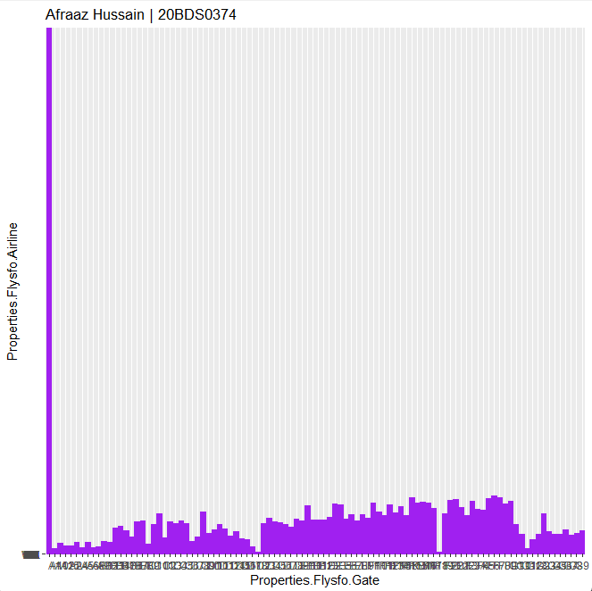

* Bar plot with coordinate flip:

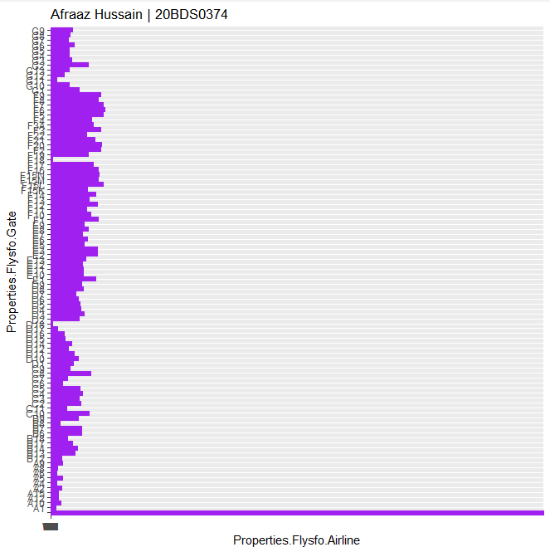

* Bar plot with error bars:

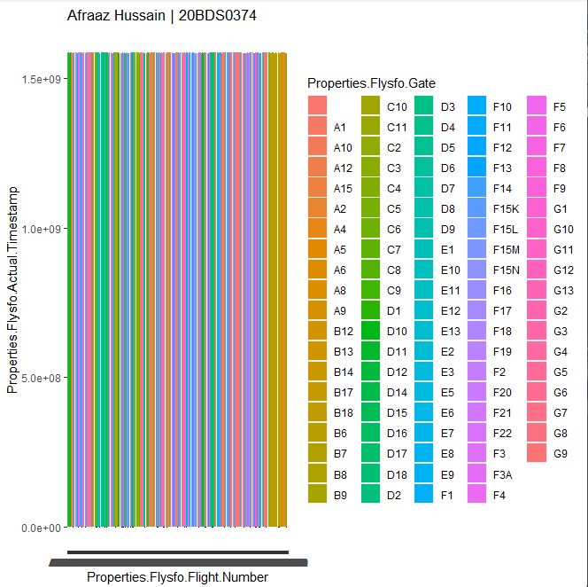

* Stacked bar plot:

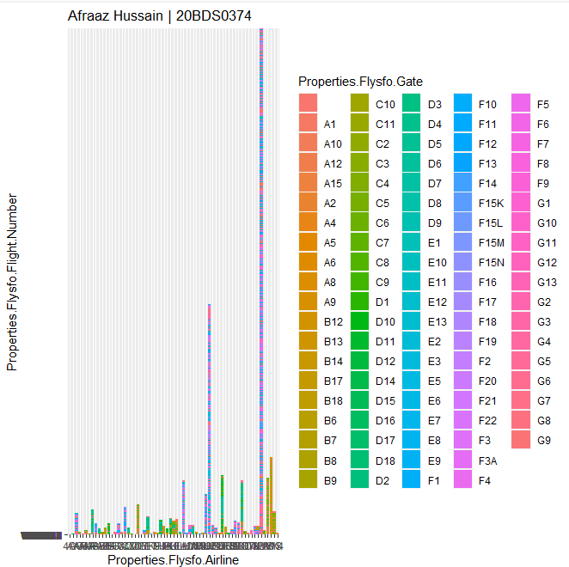

* Scatter plot with blank diamond:

* Scatter plot with flipped triangle:

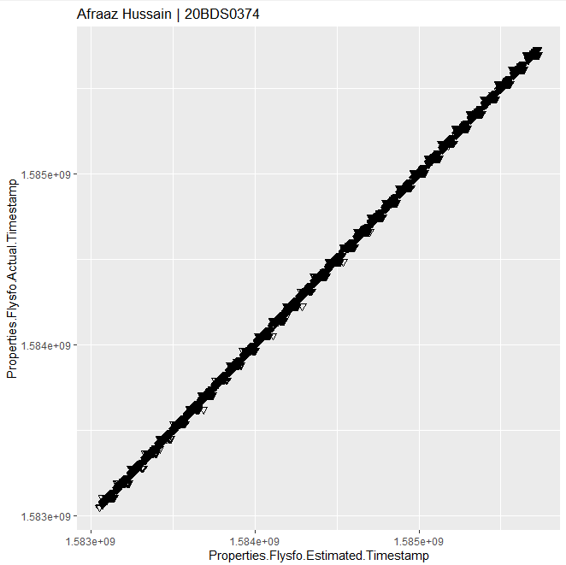

**QUESTION:**

The dataset from looker needs to taken and create the visualization using looker studio. Take the screen shot of Dashboard and Share the link=Sharing option Document to be uploaded in PDF.

**OUTPUT:**

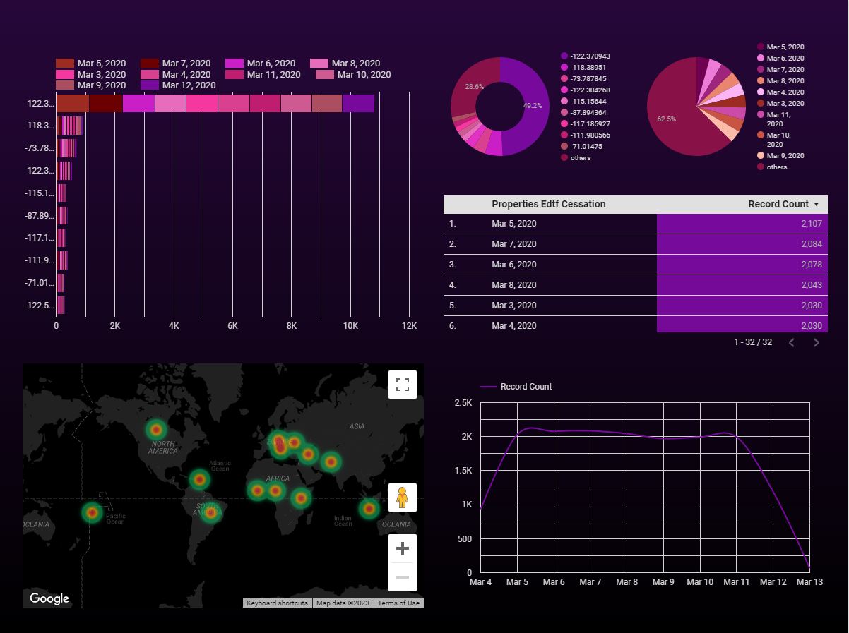

**LINK:**

https://lookerstudio.google.com/reporting/7464e576-a7ad-4f98-81d0-4c1a39aab0c3